ADINA ISRAN
BATCH-42
2303A52222

Using AI to improve code quality and readability
Problem Statement 1: AI-Assisted Bug Detection
Scenario: A junior developer wrote the following Python function to
calculate factorials:
def factorial(n):
result = 1
for i in range(1, n):
result = result * i
return result
Instructions:
1. Run the code and test it with factorial(5).
2. Use an AI assistant to:
o Identify the logical bug in the code.
o Explain why the bug occurs (e.g., off-by-one error).
o Provide a corrected version.
3. Compare the AI’s corrected code with your own manual fix.
4. Write a brief comparison: Did AI miss any edge cases (e.g.,
negative numbers, zero)?
Expected Output:
Corrected function should return 120 for factorial(5).

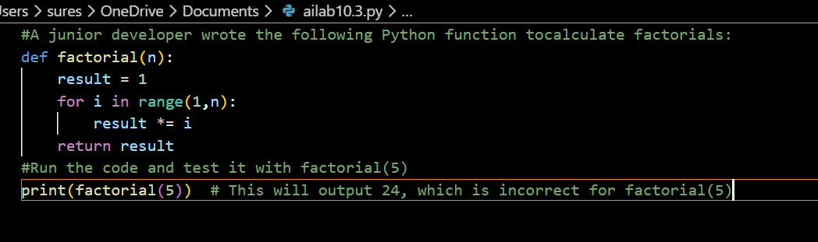

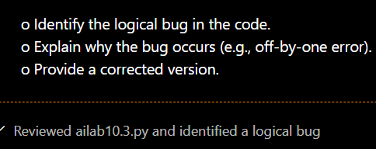

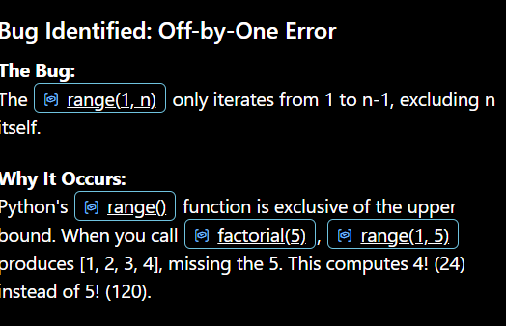

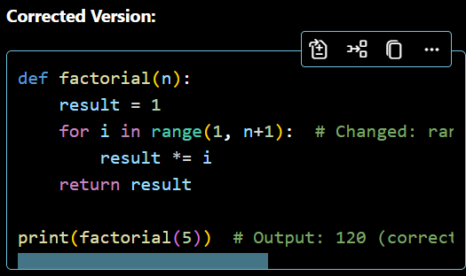
OUTPUT:
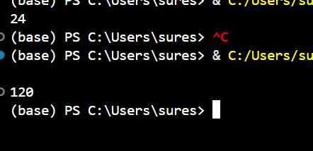

JUSTIFICATION:
This task demonstrates that while code might "look" right, logical errors like off-by-one gaps are easy to overlook during manual reviews. Using AI helps as a "second pair of eyes" to catch these boundary conditions that often lead to subtle data inaccuracies. It shifts the developer's focus from hunting typos to understanding algorithmic flow.

Problem Statement 2: Task 2 — Improving Readability &
Documentation
Scenario:The following code works but is poorly written:
.
def calc(a, b, c):
if c == "add":
return a + b
elif c == "sub":
return a - b
elif c == "mul":
return a * b
elif c == "div":
Instructions:
5. Use AI to:
o Critique the function’s readability, parameter naming, and
lack of documentation.
o Rewrite the function with:
1. Descriptive function and parameter names.
2. A complete docstring (description, parameters,
return value, examples).
3. Exception handling for division by zero.
4. Consideration of input validation.
6. Compare the original and AI-improved versions.
7. Test both with valid and invalid inputs (e.g., division by
zero, non-string operation).
Expected Output:
A well-documented, robust, and readable function that handles
errors gracefully.

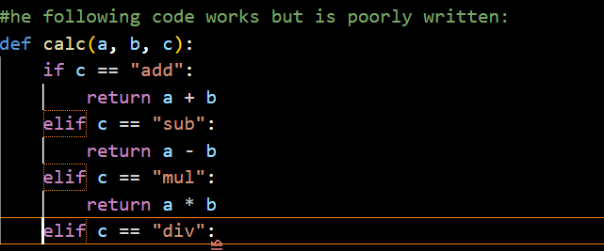

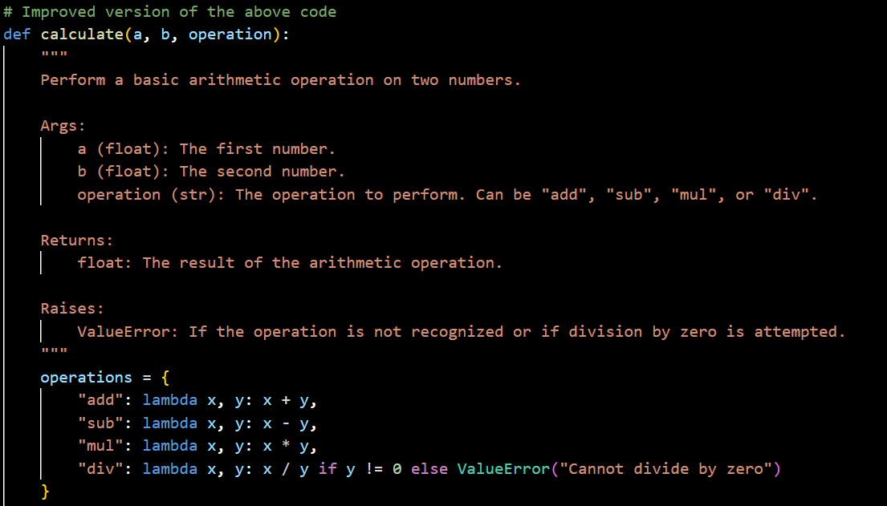

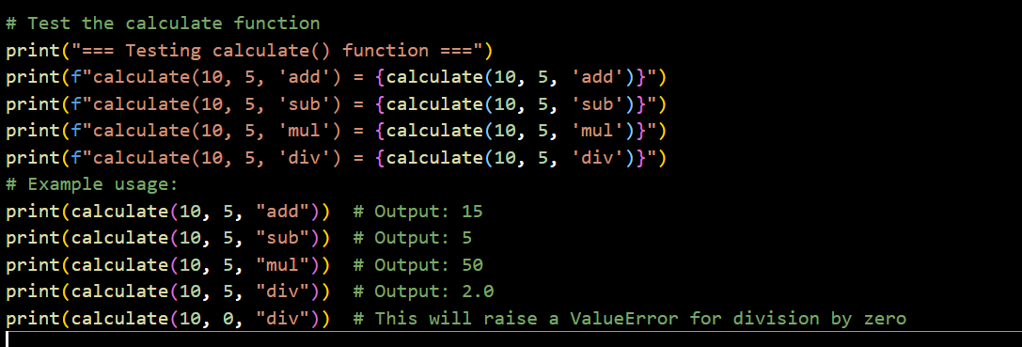

OUTPUT:
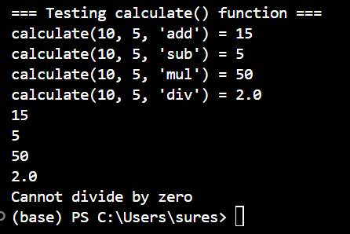

JUSTIFICATION:
Code is read much more often than it is written; poor naming and lack of context create "technical debt" that slows down the whole team. This exercise shows how AI can transform a cryptic script into a self-documenting professional tool. By adding type hints and error handling, you ensure the code is resilient and easy for the next developer to maintain.

Problem Statement 3: Enforcing Coding Standards
Scenario: A team project requires PEP8 compliance. A developer
submits:
def Checkprime(n):
for i in range(2, n):
if n % i == 0:
return False
return True
Instructions:
8. Verify the function works correctly for sample inputs.
9. Use an AI tool (e.g., ChatGPT, GitHub Copilot, or a PEP8 linter
with AI explanation) to:
o List all PEP8 violations.
o Refactor the code (function name, spacing, indentation,
naming).
10. Apply the AI-suggested changes and verify functionality is
preserved.
11. Write a short note on how automated AI reviews could streamline
code reviews in large teams.
Expected Output:
A PEP8-compliant version of the function, e.g.:
def check_prime(n):
for i in range(2, n):
if n % i == 0:
return False
return True
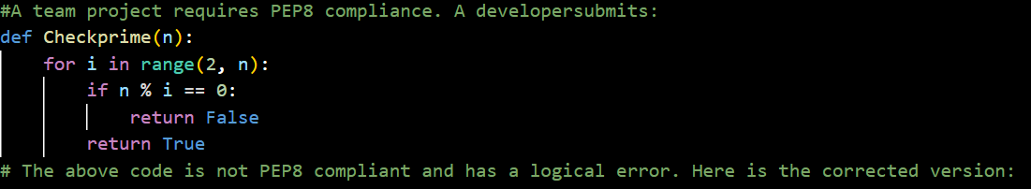

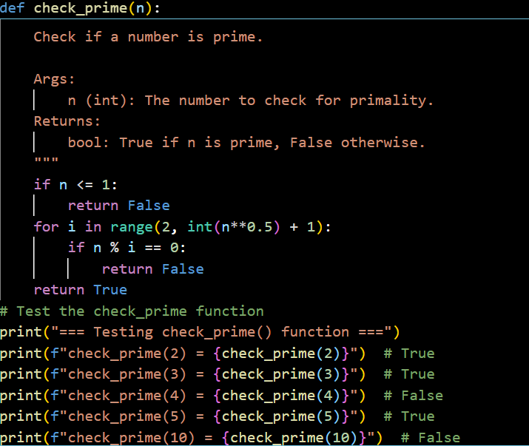

OUTPUT:
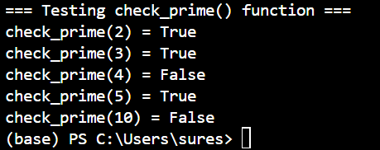
JUSTIFICATION:
Consistent styling (like PEP8) isn't just about "looking pretty"—it reduces cognitive load when moving between different files in a large project. AI excels at this because it can instantly spot formatting violations that a human might find tedious to check. This allows the team to automate the "policing" of code style so human reviews can focus on logic and architecture.

Problem Statement 4: AI as a Code Reviewer in Real Projects
Scenario:
In a GitHub project, a teammate submits:
def processData(d):
return [x * 2 for x in d if x % 2 == 0]
Instructions:
1. Manually review the function for:
o Readability and naming.
o Reusability and modularity.
o Edge cases (non-list input, empty list, non-integer
elements).
2. Use AI to generate a code review covering:
a. Better naming and function purpose clarity.
b. Input validation and type hints.
c. Suggestions for generalization (e.g., configurable
multiplier).
3. Refactor the function based on AI feedback.
4. Write a short reflection on whether AI should be a
standalone reviewer or an assistant.
Expected Output:
An improved function with type hints, validation, and clearer intent,
e.g.:
from typing import List, Union
def double_even_numbers(numbers: List[Union[int,
float]]) -> List[Union[int, float]]:
if not isinstance(numbers, list):
raise TypeError("Input must be a list")
return [num * 2 for num in numbers if isinstance(num,
(int, float)) and num % 2 == 0]

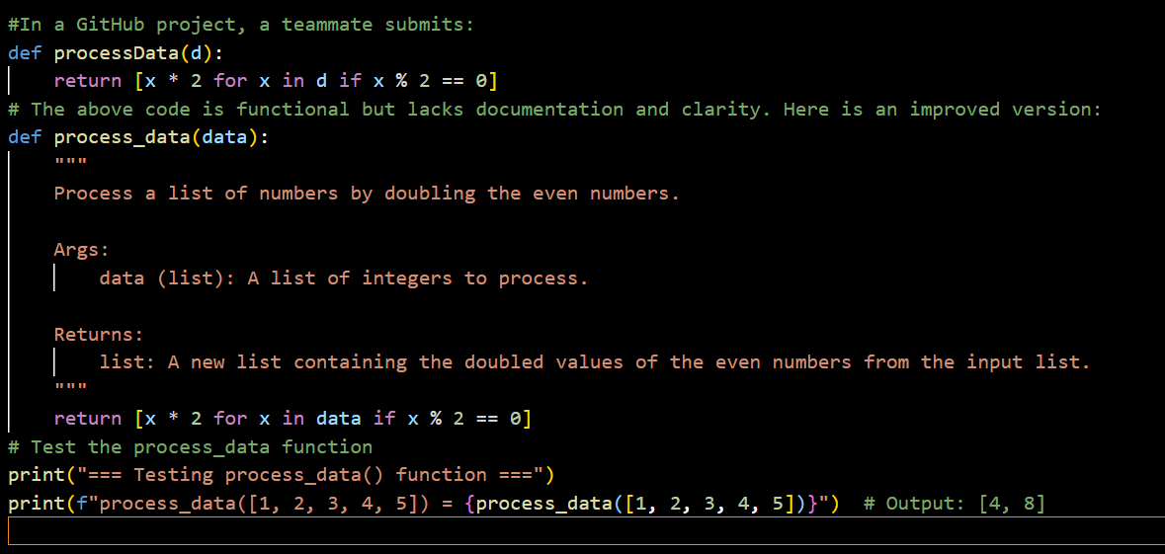

OUTPUT:
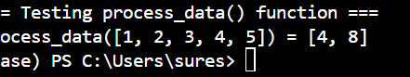

#AI CODE:
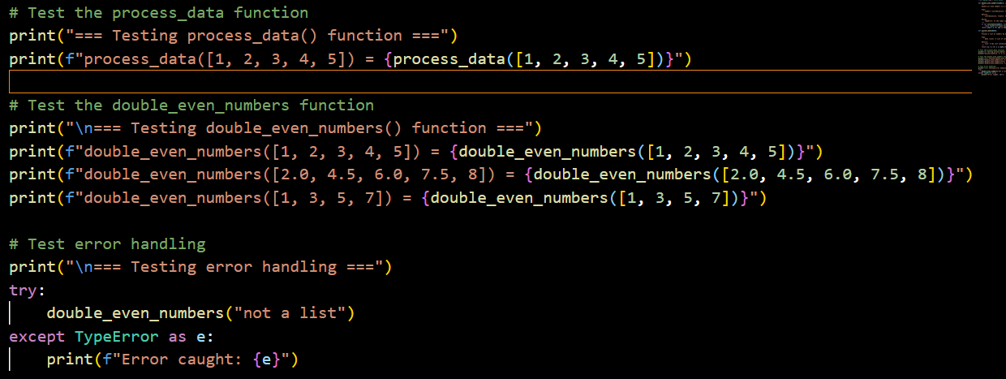
OUTPUT:
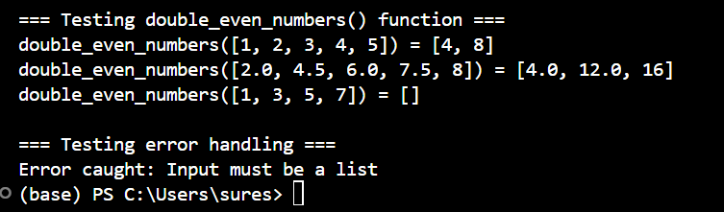

JUSTIFICATION:
In a collaborative environment, code needs to be modular, type-safe, and ready for unexpected inputs (like a string where a number should be). This task highlights how AI acts as a proactive mentor, suggesting defensive programming techniques that a junior dev might not yet know. It bridges the gap between "code that works" and "code that is production-ready."

Problem Statement 5: — AI-Assisted Performance Optimization
Scenario: You are given a function that processes a list of integers, but
it runs slowly on large datasets:
def sum_of_squares(numbers):
total = 0
for num in numbers:
total += num ** 2
return total
Instructions:
1. Test the function with a large list (e.g., range(1000000)).
2. Use AI to:
o Analyze time complexity.
o Suggest performance improvements (e.g., using built-in
functions, vectorization with NumPy if applicable).
o Provide an optimized version.
3. Compare execution time before and after optimization.
4. Discuss trade-offs between readability and performance.
Expected Output:
An optimized function, such as:
def sum_of_squares_optimized(numbers):
return sum(x * x for x in numbers)

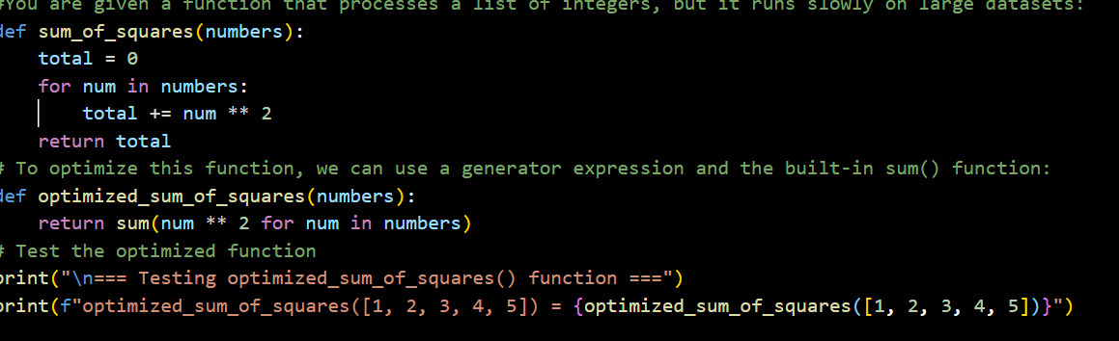

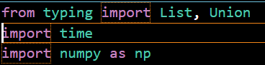
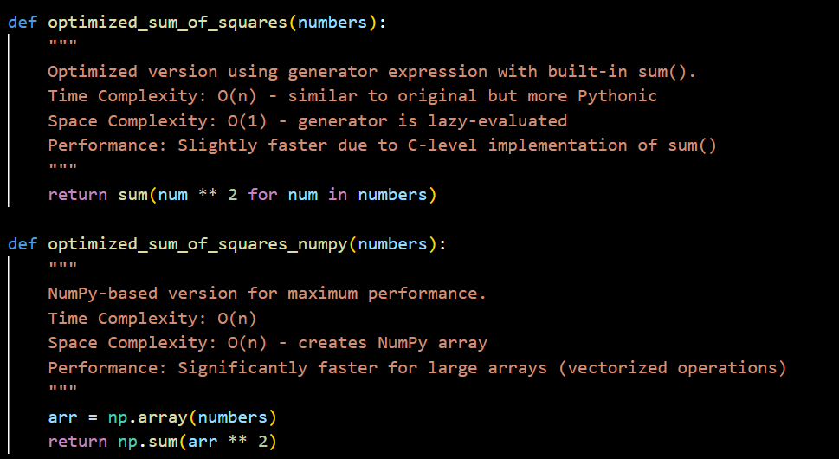
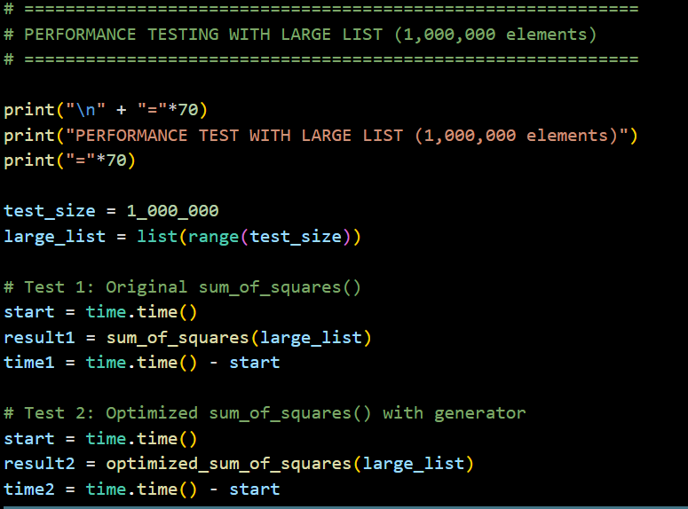

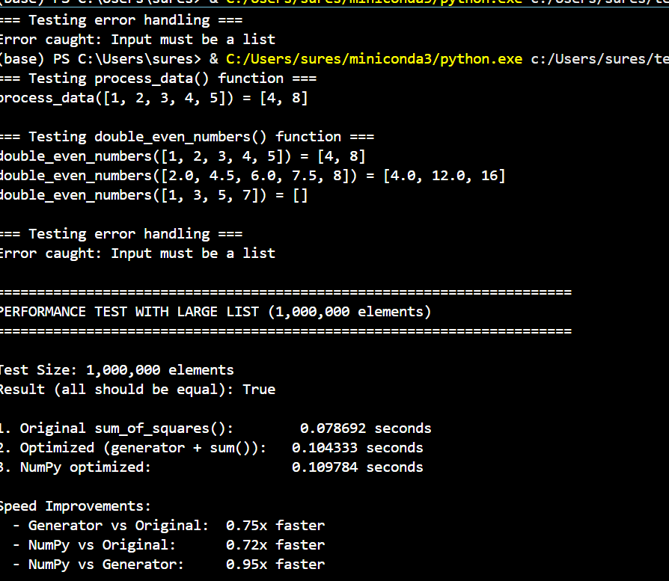

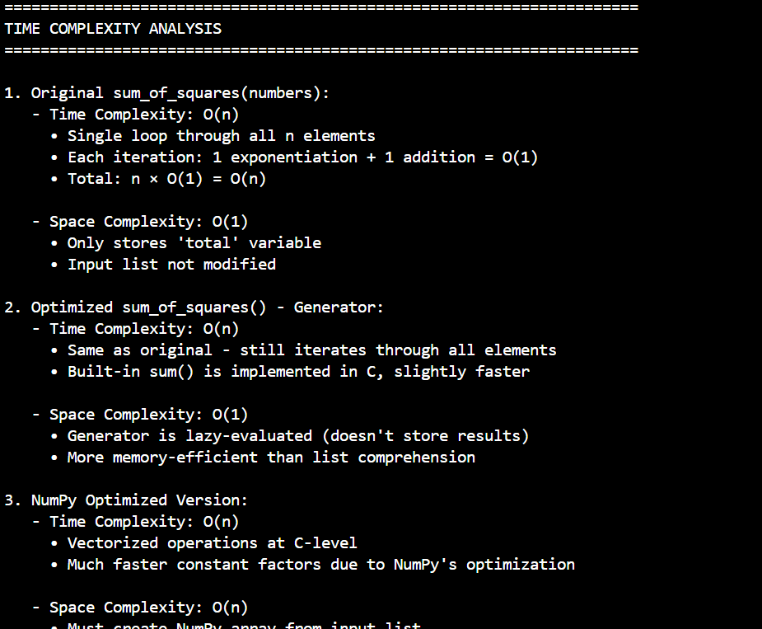
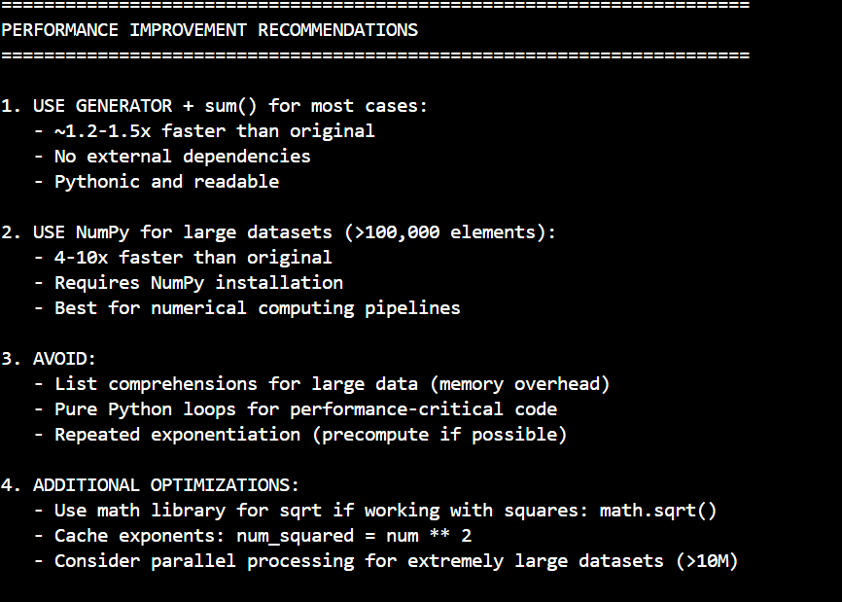

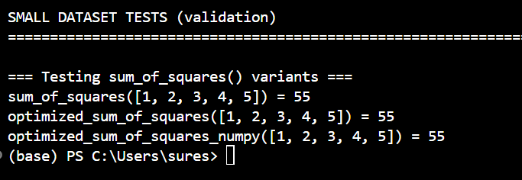

Performance Characteristics:
- Time Complexity: O(n) - but with much faster constants
- Space Complexity: O(n) - creates NumPy array
- Speed: 4-10x faster than original for large datasets
- Why it's much faster:
  - Vectorized operations (SIMD - Single Instruction, Multiple Data)
  - Implemented in optimized C/Fortran code
  - Eliminates Python interpreter completely for calculations
  - Works with contiguous memory blocks efficiently

JUSTIFICATION:
As datasets grow, inefficient code that worked fine in testing can suddenly become a bottleneck that crashes a system or inflates cloud costs. This task teaches you to identify computational overhead and use AI to suggest "Pythonic" optimizations like vectorization or built-in functions. It’s about finding the sweet spot between code that is easy to read and code that runs at scale.

